Extreme Word Guessing Game

Protocol Definition

# Overview

This document defines the communication protocols for an interactive multi-player game, called the *Extreme Word Guessing Game*. The system needs includes two kinds of software components (processes) that will communicate with each other, namely a *Player* and a *Word Server*. The next section outlines the various types of conversations that may occur between these components and the general communication patterns that these conversations follow. It also defines messages that the protocols involves. The section after that defines how the software components must encode and decode them so they understand each other.

# Conversations, Communication Patterns, and Messages

Table 1 lists the possible types of conversations involved in this system, along with which component initiates the conversation, other components involved, and general communication pattern. The communication pattern defines the possible message sequences in both normal and abnormal conditions. (Note that this game is a simple client-server system with only two component and one communication pattern. Nevertheless, this documentation uses a slightly more robust table to illustrate one way of describing a more complex set of protocols.) The only communication pattern used here is *Request-Reply* with various request messages that come from the list of specialization of the *Request* class in Figure 1 and reply messages that come from the list of specializations of the *Reply* class in Figure 1*.* Figures 2-4 illustrate the possible message sequences for the *Request-Reply* pattern.

**Table 1 – Conversations and Protocols for the *Extreme Word Guessing Game***

|  |  |  |  |
| --- | --- | --- | --- |
| **Protocol / Conversation** | **Initiator** | **Other Participants** | **Communication Pattern** |
| Registration  *registers a new user* | Player | Word Server | *Request-Reply*, with *Registration* and *AckNak* as the messages |
| Login  *Logs a user in and creates a session, during which the user can create or join multiple games* | Player | Word Server | *Request-Reply*, with *Login* and *AckNak* as the messages |
| ListGames | Player | Word Server | *Request-Reply*, with *GetGameList* and *GameList* as the messages |
| NewGame  *Creates a new game* | Player | Word Server | *Request-Reply*, with *NewGame* and *WordDef* as the messages |
| JoinGame  *Joins the player to an existing game, discover from the list of existing games.* | Player | Word Server | *Request-Reply*, with *JoinGame* and *WordDef* as the messages |
| StartGame  *Starts a game that has at least two players and hasn’t been started yet.* | Player | Word Server | *Request-Reply*, with *StartGame* and *AckNak* as the messages |
| GuessWord  *Allows the player to guess a word in a game and know if it right or not.* | Player | Word Server | *Request-Reply*, with *GuessWord* and *Answer* as the messages |
| GetHint  *Allows the player to request another hint in a game.* | Player | Word Server | *Request-Reply*, with *GetHint* and *WordDef* as the messages |
| ExitGame  *Exists the player from a game* | Player | Word Server | *Request-Reply*, with *ExitGame* and *AckNak* as the messages |
| Logout  *Log a player out, terminate that player’s session* | Player | Word Server | *Request-Reply*, with *Logout* and *AckNak* as the messages |

**Figure 1 – Message Classes**

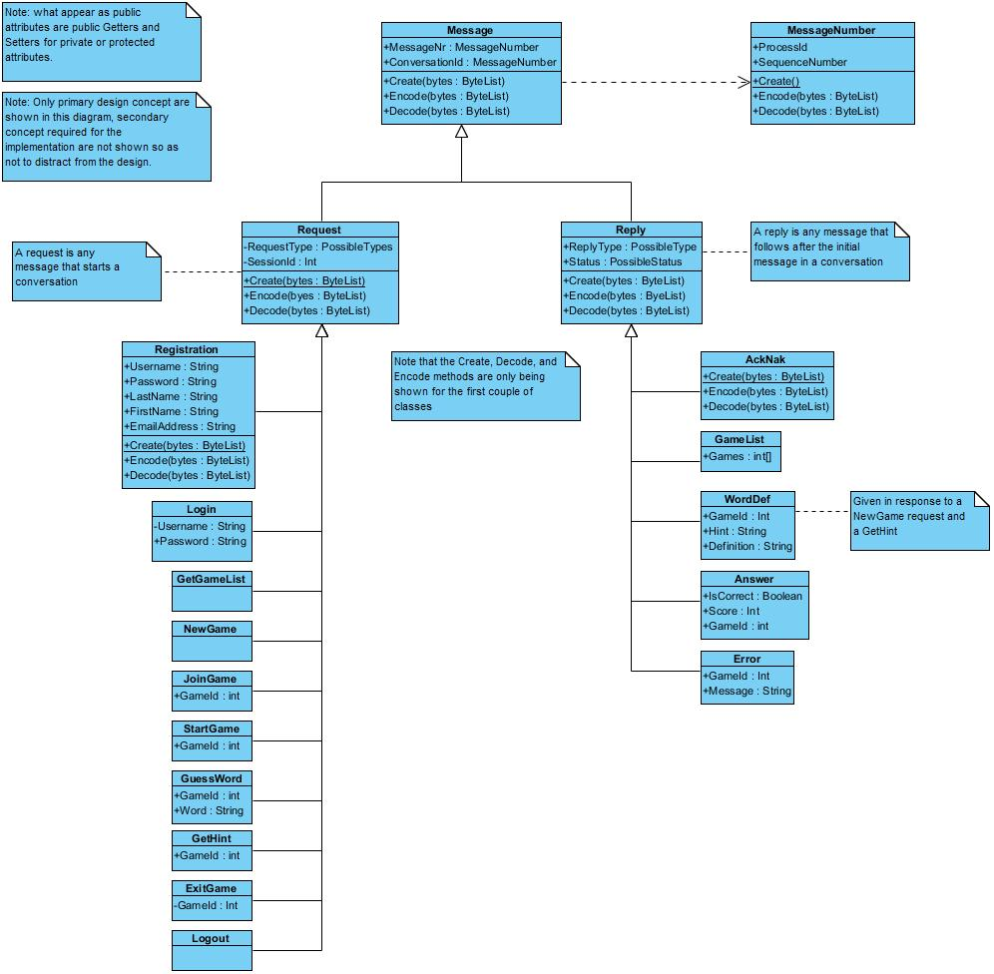

**Figure 2 – A successful a Request-Reply conversation**

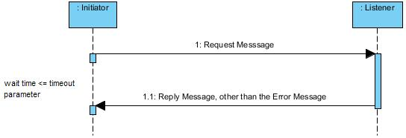

**Figure 3 – A timeout situation for a Request-Reply conversation**

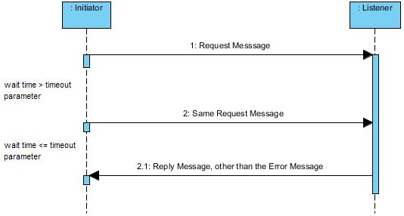

**Figure 4 – An aborted Request-Reply conversation**

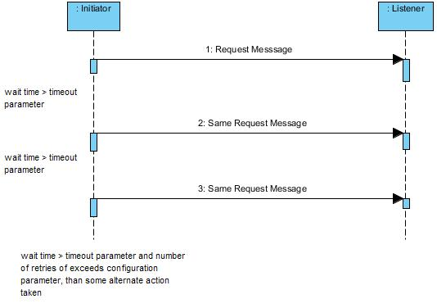

# Message Encoding / Decoding

A message will be encoded recursively using the following rules:

1. The encoding of a *Message* object involves writing its Class Id, the length of its encoded properties, and its properties into a ByteList.
   1. The encoding properties process is a pre-defined order of the class
   2. Each property is encoded as follows:
      1. A primitive numeric value (e.g. an integer) is written out in network byte order
         1. Byte – 1 byte
         2. Int16 – 2 bytes
         3. Int32 – 4 bytes
         4. Int64 – 8 bytes
         5. Single Precision Real – 4 bytes
         6. Double Precision Real – 4 bytes
      2. A char is encoded by writing a two-byte Unique representation of the char value.
      3. A string is encoded by writing out its length as an Int16 (in network byte order) and a sequence of bytes, where the bytes are a Unicode representation of the string.
      4. A Boolean value is written out as a byte with a value of 0 (false) or 1 (true)
      5. An array or list of primitive values is encoded by first writing out the count of elements in the array or list as an Int16 (in network byte order), followed by an encoding of each value following rules 1.2.1 – 1.2.4
      6. A property whose value is object is encoded following Rule 1 recursively.
      7. An array or list of objects is encoded by first writing out the count of elements in the array or list as an Int16 (in network byte order), followed by an encoding of each object following Rule 1

# Message Semantics

*To Be Written*